Wiosenne kwiaty

Rozwiąż krzyżówkę.

|  |  |  |  |  |  |  |  |  |  |  |  |  |  |  |  |  |  |
| --- | --- | --- | --- | --- | --- | --- | --- | --- | --- | --- | --- | --- | --- | --- | --- | --- | --- |
| 1 |  |  |  |  |  |  |  |  |  |  |  | J |  |  |  | | |
|  | | | | 2 | | |  | U |  |  |  |  |  |
| 3 | | | | Ż |  |  |  |  |  |
| 4 |  |  |  | W |  |  |  |  |  |
|  | | 5 | | |  |  |  | I |  |  |  |  |
|  | | | 6 |  |  | O |  |  |  |  | |
| 7  8 |  |  |  |  |  |  |  | S |  |  |  |
|  |  |  |  |  |  |  | N |  |  |  |
| 9 | |  |  |  |  |  |  |  |  | A |  | | |
|

7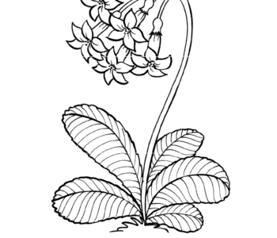 6 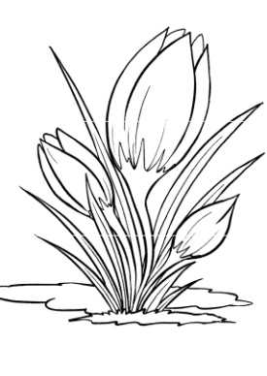 8 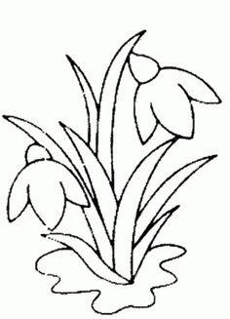 5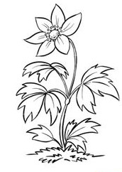 9 4 2 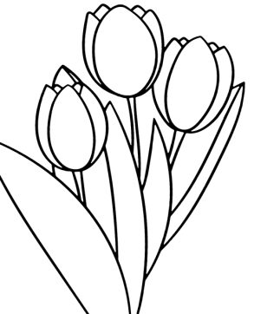

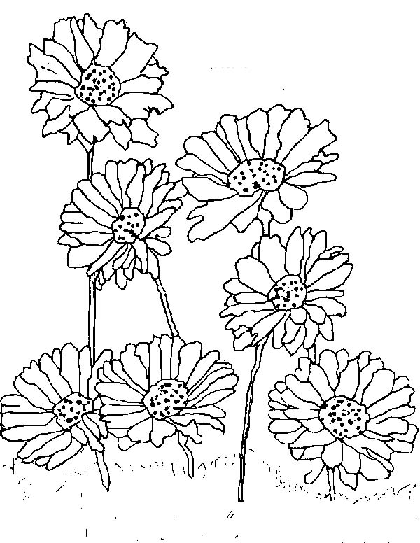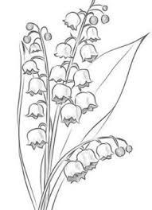

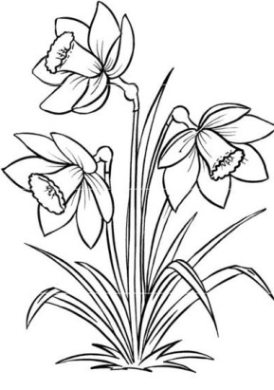

1 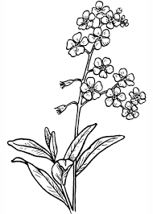 3